

GROUP PROJECT REPORT

Statistics



**Supervised By:**

**Ms. TILINI DAHRMASENA**

**Group Members**

GAHDSE23.1F-002 -: Dimuth Nilanjana

GAHDSE23.1F-004 -: Hiru Amarajeewa

GAHDSE23.1F-009 -: DIleesha Bandara

GAHDSE23.1F-031 -: Hirumi Minasha

AUGUST 10, 2023

NIBM

## ACKNOWLEDGMENT

This note to acknowledge was created for expressing our gratitude and appreciation to everyone who supported us and advised us in various ways throughout the course of this project. First and foremost, we would like to express our gratitude to Ms. Thilini Dharmasena for her invaluable advice and constant encouragement throughout the project.

We would like to show gratitude to our friends and all those who directly and indirectly contributed to the successful completion of this project. Finally, we would want to express our gratitude to our classmates and those who assisted us in finishing this project.

Date………….

Reg. No…………

# ABSTRACT

This research explores entrepreneurial intentions among Generation Z youth in Sri Lanka. The goal of this study is to analyze the variables impacting entrepreneurial inclinations in this age group while taking Sri Lanka's sociocultural, economic, and technological contexts into account. This research project aims to uncover impediments preventing Sri Lanka's Generation Z from pursuing their entrepreneurial ambitions by utilizing various approaches, including surveys and qualitative interviews.

The study draws on planned behavior and incorporates social and technological acceptance model components. The research identified several variables as potential predictors of entrepreneurial intents in the chosen populations, including personal attitudes, perceived behavioral control, subjective norms, technology familiarity, target perception, and cultural influences.

A structured survey that was sent to a broad sample of Generation Z people in several parts of Sri Lanka was used to acquire the primary data. They will be questioned in this survey about their opinions on entrepreneurship, perceived obstacles, use of technology, and sociocultural factors.

The results of this study could be useful for both theoretical and practical purposes. Theoretically, exploring the Sri Lankan development of Generation Z broadens our knowledge of entrepreneurial goals.

It can serve as a guide for educators, policymakers, and other industry players in developing programs and policies to support an environment that encourages young entrepreneurship. This study intends to raise funds to support the development of Sri Lanka's future generation of entrepreneurs by providing light on the motivations, difficulties, and goals of Generation Z in the field of entrepreneurship.

## TABLE OF CONTENT

Acknowledgement ...........................................................................................................................1

Abstract ............................................................................................................................................2

Introduction ......................................................................................................................................4

Problem Statements ........................................................................................................................5

Project Objectives ...........................................................................................................................6

Methodology ...................................................................................................................................7

Population, sample, and Sampling technique .................................................................................7

Data Collection Methods .................................................................................................................8

Questionary ......................................................................................................................................8

Subjective and Social norms ............................................................................................................9

Chart ...............................................................................................................................................10

Data Analysis .................................................................................................................................11

Discussion ......................................................................................................................................30

Recommendation ...........................................................................................................................32

Conclusion .....................................................................................................................................34

References ......................................................................................................................................35

Appendices .....................................................................................................................................36

**CHAPTER 01:**

# INTRODUCTION

In real life, it can serve as a guide for educators, policymakers, and other industry players in developing programs and policies to support an environment that encourages young entrepreneurship. This study intends to raise funds to support the development of Sri Lanka's next generation of entrepreneurs by providing insight into the motivations, challenges, and goals of Generation Z in the field of entrepreneurship.

In this context, this research aims to explore the variables that support or limit the entrepreneurial aspirations of Sri Lanka's Generation Z. This study intends to offer insightful contributions to the overall discussion on young entrepreneurship by exploring their opinions on entrepreneurship, their interactions with technology, and the influences of their cultural environment. The results also have the potential to guide tactics and policies that support an environment where Generation Z's entrepreneurial spirit can grow, which will benefit the young people and the economy of the country.

A convenience sample was used to make the research successful. According to it there are four independent variables and one dependent variable in the research. Independent variables include Attitudes, Personality traits, social norms, and Entrepreneurial opportunities and dependent variables are Entrepreneurial intention among Generation Z in Sri Lanka.

**PROBLEM STATEMENT**

There continues to be a lack of thorough research that focuses exclusively on the entrepreneurial goal of Generation Z, despite the growing attention paid to entrepreneurship in Sri Lanka. A difficult convergence of traditional beliefs and contemporary innovations is being handled by this demographic group, which is identified by its distinctive traits and technological immersion. It is vital to understand the variables which define the entrepreneurial aspirations of this generation as the nation experiences social and cultural shifts and increases its implementation of technology.

While research has already been conducted regarding new entrepreneurs in Sri Lanka, they frequently failed to consider the attitudes, views, and actions of Generation Z. There is therefore little understanding of how this generation's distinctive fusion of cultural values and technological connections affects their interest in business. Furthermore, the present research often stops short in offering a thorough knowledge of the difficulties and opportunities Generation Z entrepreneurs in Sri Lanka face when pursuing their business processes.

By analyzing the fundamental factors that support or harm the self-employment goals of Sri Lanka's Generation Z, this research aims to close these gaps. This study seeks to provide a more comprehensive understanding of their objectives by studying their perspectives on entrepreneurship, their relationship with technology, and the cultural factors that influence their worldview. In addition to adding to the scholarly discussion on youth entrepreneurship, the findings of this study will also provide politicians, educators, and business leaders in Sri Lanka with practical advice on how to create an environment that is supportive to young people's pursuit of entrepreneurship.

# Project Objectives:

1. **Explore Attitudes and Perceptions:**

To investigate the attitudes of Generation Z individuals in Sri Lanka towards entrepreneurship, understanding their perceptions of the concept and its relevance in their lives.

1. **Identify Influencing Factors:**

To identify the key factors that influence the entrepreneurial intentions of Generation Z in Sri Lanka, considering both internal (personal attitudes, perceived control) and external (cultural norms, technological familiarity) determinants.

1. **Assess Technological Adoption:**

To assess the level of technological adoption among Generation Z in Sri Lanka and determine how their familiarity with technology impacts their entrepreneurial aspirations.

1. **Examine Cultural Impact:**

To examine the role of cultural factors in shaping the entrepreneurial intentions of Generation Z in

Sri Lanka, understanding how traditional values and evolving norms interact with their aspirations.

1. **Provide Actionable Insights:**

To provide actionable insights for policymakers, educators, and industry stakeholders on how to cultivate an environment that supports and encourages the entrepreneurial aspirations of Generation Z in Sri Lanka, fostering economic growth and innovation.

**CHAPTER 02:**

# METHODOLOGY

This chapter is mainly focused on describing the research's flow based on its primary key points.

This chapter begins with an explanation of the procedures used for data gathering, sampling, and analysis. The conceptual framework that we used in this research will be explained in the final section of this chapter.

# Population, sample, and Sampling technique

The younger crowd was used as the research's target audience, and 70 young individuals were chosen as the study's sample. The method of sampling is practical sampling. 70 young persons were therefore chosen as the sample.



Selected

70

youn

g

people’s

.



Population



Sample



All Younger crowd

# Data collection Methods

The online survey that was sent to all of the young people served as the primary source of data for this study. The primary conceptual framework provided in the parts below is the focus of this inquiry. 70 responses to the survey were used in the research analysis procedure.

[This link displays the questionnaire we developed to gather data.](https://forms.gle/uXWLRT7DwWE3Y1FL8)

# Questionary

### Attitudes

1. As a youngster rate your preference to start a new business.
2. As a youngster how frequently, new ideas come into your mind.
3. Rate your capacity to think out of the box.
4. As a youngster how logical you are?
5. As a youngster, you are an interactive participant in new social activities.
6. As a youngster, you are supportive of new ideas and trends in society?
7. As a youngster, you collaborate and work with others to initiate new business ideas?.
8. As a youngster If you like to take risks when starting new things?
9. As a youngster, do you have positive ideas about new things?

### Personality Traits

1. As a youngster, you are willing to take on new opportunities in your life.
2. As a youngster, your willingness to do new things with your feelings.

# Subjective and Social norms

1. As a youngster, you are a social believer.
2. As a youngster you are following business rules and regulations when are you starting a new thing?
3. As a youngster, you are dependent on cultural and religious limits when you are starting new things
4. As a youngster are you looking for new trends when you start new things?
5. As a youngster, are you doing new things according to fundamental strategies and knowledge?

### Entrepreneurial Opportunities

1. As a youngster, you are receiving opportunities from society to initiate new things.
2. As a youngster when you do new things can there be any impact from the generation gap?
3. As a youngster, your family helps you to start new things?
4. As a youngster, your education helps you to start new things.?
5. Rate your view about the ease of finding new information when you start new things.
6. Availability of information when you are starting new things.

### Entrepreneurial Intention among Generation Z in Sri Lanka

1. As a youngster rate your capability to start your own business after ending your education?
2. As a youngster, you have good intentions about entrepreneurship?

# Chart



**Subjective and Social**

**norms**



**Entrepreneurial**

**Opportunities**

**Dependent**

**Variables**

**Independent**

**Variables**



**Personalit**

**y**

**Traits**



**Entrepreneurial Intention**

**among Generation Z in Sri**

**Lanka**



**Attitudes**

**CHAPTER 03:**

# DATA ANALYSIS

The final data analysis from the questionnaire, which was developed using the conceptual framework outlined in the preceding chapter, is contained in this chapter. IBM (SPSS) and Microsoft Excel software were used to evaluate this data.

**Independent Variable 01: Attitudes**

**Normal Probability Plot:**

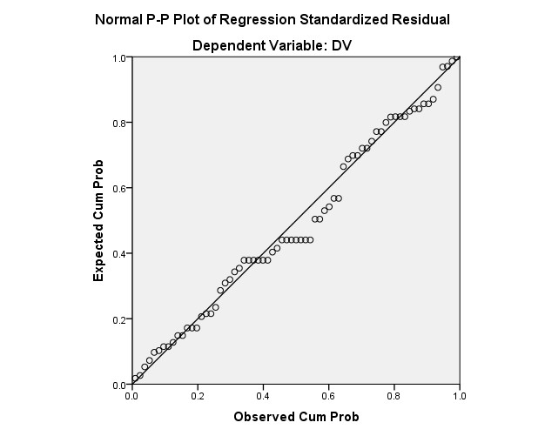

This graph shows Positive Covariance behavior. Therefore, it visually interprets how youngest people’s mind and thinking patterns change their **Attitudes** in **Entrepreneurial Intention among Generation Z in Sri Lanka.**

### Summary Table

**Model Summaryb**

|  |  |  |  |  |
| --- | --- | --- | --- | --- |
| Model | R | R Square | Adjusted R  Square | Std. Error of the  Estimate |
| 1 | .627a | .393 | .384 | 1.119 |

1. Predictors: (Constant), IV1
2. Dependent Variable: DV

**Model R**: This is the correlation coefficient between the observed values of the dependent variable (DV) and the predicted values from the model. In this case, it is 0.627.

**R Square:** Also known as the coefficient of determination, R Square indicates the proportion of the variance in the dependent variable that is explained by the variance in the independent variable. In this model, approximately 39.3% (0.393) of the variability in the "Entrepreneurial Intention among Generation Z in Sri Lanka" can be attributed to variations in the "Attitudes" variable.

**Adjusted R Square:** This adjusts R Square for the number of predictors in the model, providing a more accurate measure of the model's explanatory power. Here, it's 0.384.

**Std. Error of the Estimate:** This is an estimate of the standard deviation of the residuals, which are the differences between the observed and predicted values. It gives an indication of how well the model's predictions match the actual data points. In this case, the standard error is 1.119.

### ANOVA Table

**ANOVAa**

|  |  |  |  |  |  |  |
| --- | --- | --- | --- | --- | --- | --- |
| Model |  | Sum of Squares | df | Mean Square | F | Sig. |
| 1 | Regression | 54.373 | 1 | 54.373 | 43.412 | .000b |
| Residual | 83.917 | 67 | 1.252 |  |  |
| Total | 138.290 | 68 |  |  |  |

1. Dependent Variable: DV
2. Predictors: (Constant), IV1

A significant level (Sig) value of 0.000 is given in the ANOVA table.

Since the significance value is less than 0.05 (often denoted as α), which is a commonly used threshold for statistical significance, we follow the rule that if the Sig value is less than or equal to

0.05, we reject the null hypothesis (H0) and accept the alternative hypothesis (H1).

Therefore, in this case, because the Sig value is extremely low (0.000 < 0.05), we can conclude that there is indeed a significant relationship between attitudes and entrepreneurial intention among Generation Z in Sri Lanka.

### Coefficients Table

#### Coefficientsa

|  |  |  |  |  |  |  |  |  |
| --- | --- | --- | --- | --- | --- | --- | --- | --- |
| Model |  | Unstandardized  Coefficients | | Standardized  Coefficients | t | Sig. | 95.0% Confidence Interval for  B | |
| B | Std. Error | Beta | Lower Bound | Upper Bound |
| 1 | (Constant) | .950 | .516 |  | 1.841 | .070 | -.080 | 1.980 |
| IV1 | .179 | .027 | .627 | 6.589 | .000 | .125 | .233 |

a. Dependent Variable: DV

y=mx +c m= 0.179 x = Attitudes c= .950 y (Entrepreneurial Intention among Generation Z in Sri Lanka) = 0.179* (Attitudes) + .950

**Independent Variable 02: Personality traits Normal Probability Plot:**

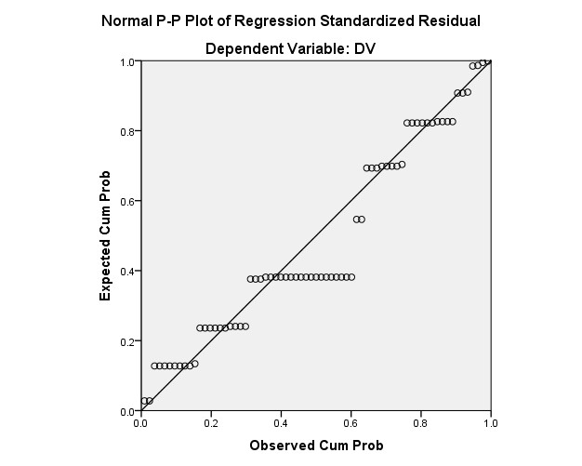

This graph shows Positive Covariance behavior. Therefore, it visually interprets how youngest people’s mind and thinking patterns change their **Personality in** **Entrepreneurial Intention among Generation Z in Sri Lanka.**

### Summary Table

**Model Summaryb**

|  |  |  |  |  |
| --- | --- | --- | --- | --- |
| Model | R | R Square | Adjusted R  Square | Std. Error of the  Estimate |
| 1 | .531a | .282 | .271 | 1.217 |

1. Predictors: (Constant), IV2
2. Dependent Variable: DV

**Model R:** This is the correlation coefficient between the observed values of the dependent variable (DV) and the predicted values from the model. In this instance, it is 0.531.

**R Square:** Also known as the coefficient of determination, R Square quantifies the proportion of the variance in the dependent variable that can be attributed to the variance in the independent variable. In this model, around 28.2% (0.282) of the variability in "Entrepreneurial Intention among Generation Z in Sri Lanka" can be explained by variations in the "Personality" variable.

**Adjusted R Square:** This value adjusts R Square to account for the number of predictors in the model, providing a more accurate measure of the model's explanatory power. Here, it's 0.271.

**Std. Error of the Estimate:** This estimate provides information about how well the model's predictions align with the actual data points by indicating the standard deviation of the residuals, which are the differences between observed and predicted values. In this case, the standard error is 1.217.

### ANOVA Table

**ANOVAa**

|  |  |  |  |  |  |  |
| --- | --- | --- | --- | --- | --- | --- |
| Model |  | Sum of Squares | df | Mean Square | F | Sig. |
| 1 | Regression | 38.977 | 1 | 38.977 | 26.296 | .000b |
| Residual | 99.313 | 67 | 1.482 |  |  |
| Total | 138.290 | 68 |  |  |  |

1. Dependent Variable: DV
2. Predictors: (Constant), IV2

A significance level (Sig) value of 0.000 is given in the ANOVA table.

Since the significance value is less than 0.05 (often denoted as α), which is a commonly used threshold for statistical significance, we apply the rule that if the Sig value is less than or equal to

0.05, we reject the null hypothesis (H0) and accept the alternative hypothesis (H1).

Therefore, in this case, because the Sig value is very low (0.000 < 0.05), we can conclude that there is indeed a significant relationship between personality traits and entrepreneurial intention among Generation Z in Sri Lanka.

### Coefficients Table

#### Coefficientsa

|  |  |  |  |  |  |  |  |  |
| --- | --- | --- | --- | --- | --- | --- | --- | --- |
| Model |  | Unstandardized  Coefficients | | Standardized  Coefficients | t | Sig. | 95.0% Confidence Interval for  B | |
| B | Std. Error | Beta | Lower Bound | Upper Bound |
| 1 | (Constant) | 2.404 | .385 |  | 6.235 | .000 | 1.634 | 3.173 |
| IV2 | .491 | .096 | .531 | 5.128 | .000 | .300 | .682 |

a. Dependent Variable: DV

y=mx +c m= 0. .491 x = Personality c= 2.404 y (Entrepreneurial Intention among Generation Z in Sri Lanka) = 0. .491* (Personality) + 2.404

**Independent Variable 03: Subjective and Social norms Normal Probability Plot:**

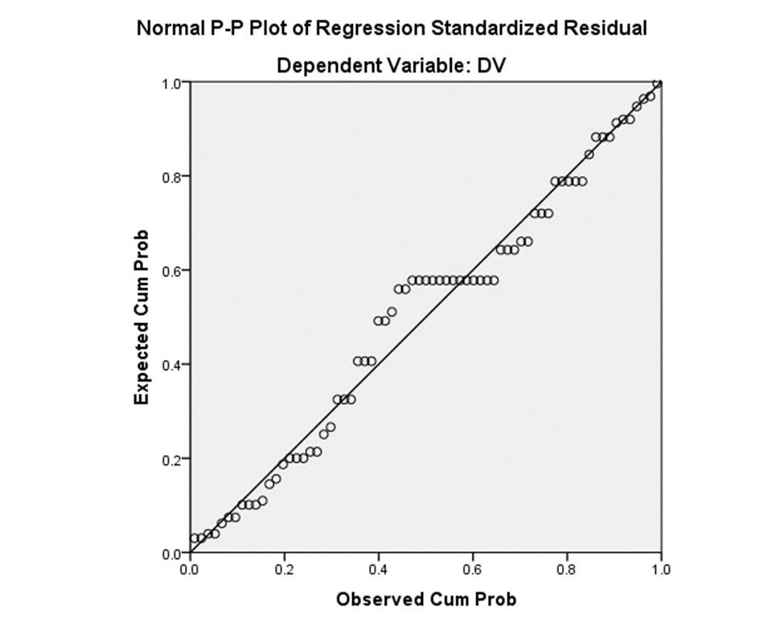

This graph shows Positive Covariance behavior. Therefore, it visually interprets how youngest people’s mind and thinking patterns change their **Subjective and Social norms in Entrepreneurial Intention among Generation Z in Sri Lanka.**

### Summary Table

#### Model Summaryb

|  |  |  |  |  |
| --- | --- | --- | --- | --- |
| Model | R | R Square | Adjusted R  Square | Std. Error of the Estimate |
| 1 | .529a | .280 | .269 | 1.219 |

1. Predictors: (Constant), IV3
2. Dependent Variable: DV

**Model R:** This value is the correlation coefficient between the observed values of the dependent variable (DV) and the predicted values from the model. In this specific case, the value is 0.529.

**R Square:** Also known as the coefficient of determination, R Square quantifies the proportion of the variance in the dependent variable that can be attributed to the variance in the independent variable. In this model, about 28.0% (0.280) of the variability in "Entrepreneurial Intention among Generation Z in Sri Lanka" can be explained by variations in the "Subjective and Social norms" variable.

**Adjusted R Square:** This value adjusts R Square to account for the number of predictors in the model, offering a more accurate measure of the model's explanatory power. In this case, it's 0.269.

**Std. Error of the Estimate:** This estimate provides information about how well the model's predictions align with the actual data points by indicating the standard deviation of the residuals, which are the differences between observed and predicted values. In this instance, the standard error is 1.219.

### ANOVA Table

**ANOVAa**

|  |  |  |  |  |  |  |  |  |
| --- | --- | --- | --- | --- | --- | --- | --- | --- |
| Model |  | Sum of Squares | df | Mean Square |  |  | F | Sig. |
| 1 | Regression | 38.747 | 1 |  |  | 38.747 | 26.080 | .000b |
|  | Residual | 99.543 | 67 |  |  | 1.486 |  |  |
| Total | 138.290 | 68 |  |  |  |  |  |

1. Dependent Variable: DV
2. Predictors: (Constant), IV3

A significance level (Sig) value of 0.000 is provided in the ANOVA table.

Since the significance value is less than 0.05 (often denoted as α), which is a commonly used threshold for statistical significance, we follow the principle that if the Sig value is less than or equal to 0.05, we reject the null hypothesis (H0) and accept the alternative hypothesis (H1). Therefore, in this case, because the Sig value is very low (0.000 < 0.05), we can conclude that there is indeed a significant relationship between subjective and social norms and entrepreneurial intention among Generation Z in Sri Lanka.

### Coefficients Table

#### Coefficientsa

|  |  |  |  |  |  |  |  |
| --- | --- | --- | --- | --- | --- | --- | --- |
| Model | Unstandardized  Coefficients | | Standardize d  Coefficients | t | Sig. | 95.0% Confidence Interval for B | |
| B | Std. Error | Beta | Lower Bound | Upper Bound |
| 1 (Constant  ) | 1.115 | .628 |  | 1.776 | .080 | -.138 .161 | 2.368 |
| IV3 | .265 | .052 | .529 | 5.107 | .000 | .368 |

a. Dependent Variable: DV

y=mx +c m= 0.265 x = Personality c= 1.115 y (Entrepreneurial Intention among Generation Z in Sri Lanka) = 0.265* (Personality) + 1.115

**Independent Variable 04: Entrepreneurial Opportunities**

**Normal Probability Plot:**

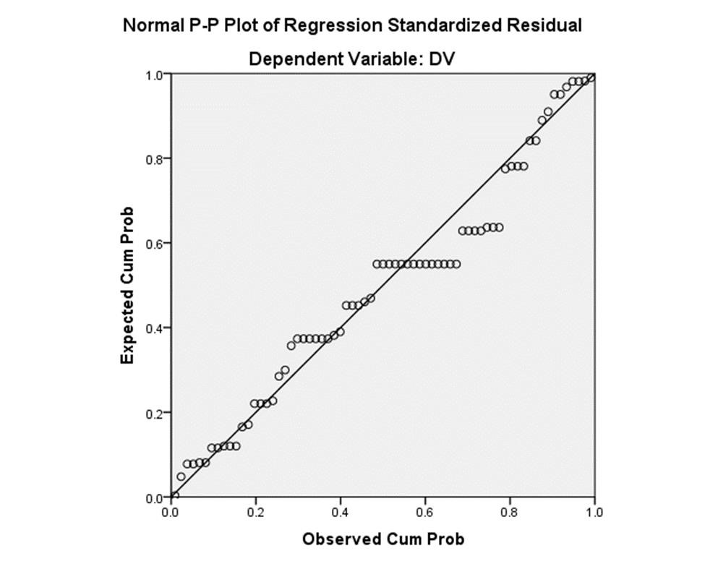

This graph shows Positive Covariance behavior. Therefore, it visually interprets how youngest people’s mind and thinking patterns change their **Entrepreneurial Opportunities** in **Entrepreneurial Intention among Generation Z in Sri Lanka.**

### Summary Table

**Model Summaryb**

|  |  |  |  |  |
| --- | --- | --- | --- | --- |
| Model | R | R Square | Adjusted R  Square | Std. Error of the Estimate |
| 1 | .605a | .366 | .357 | 1.144 |

1. Predictors: (Constant), IV4
2. Dependent Variable: DV

**Model R:** This value is the correlation coefficient between the observed values of the dependent variable (DV) and the predicted values from the model. In this specific case, the value is 0.605.

**R Square:** Also known as the coefficient of determination, R Square quantifies the proportion of the variance in the dependent variable that can be attributed to the variance in the independent variable. In this model, about 36.6% (0.366) of the variability in "Entrepreneurial Intention among Generation Z in Sri Lanka" can be explained by variations in the "Entrepreneurial

Opportunities" variable.

**Adjusted R Square:** This value adjusts R Square to account for the number of predictors in the model, offering a more accurate measure of the model's explanatory power. In this case, it's

0.357.

**Std. Error of the Estimate:** This estimate provides information about how well the model's predictions align with the actual data points by indicating the standard deviation of the residuals, which are the differences between observed and predicted values. In this instance, the standard error is 1.144.

### ANOVA Table

**ANOVAa**

|  |  |  |  |  |  |  |
| --- | --- | --- | --- | --- | --- | --- |
| Model |  | Sum of Squares | df | Mean Square | F | Sig. |
| 1 | Regression | 50.622 | 1 | 50.622 | 38.688 | .000b |
| Residual | 87.668 | 67 | 1.308 |  |  |
|  | Total | 138.290 | 68 |  |  |  |

1. Dependent Variable: DV
2. Predictors: (Constant), IV4

A significance level (Sig) value of 0.000 is given in the ANOVA table.

Since the significance value is less than 0.05 (often denoted as α), which is a commonly used threshold for statistical significance, we adhere to the guideline that if the Sig value is less than or equal to 0.05, we reject the null hypothesis (H0) and accept the alternative hypothesis (H1). Therefore, in this case, since the Sig value is very low (0.000 < 0.05), we can conclude that there is indeed a significant relationship between entrepreneurial opportunities and entrepreneurial intention among Generation Z in Sri Lanka.

### Coefficients Table

#### Coefficientsa

|  |  |  |  |  |  |  |  |
| --- | --- | --- | --- | --- | --- | --- | --- |
| Model | Unstandardized  Coefficients | | Standardize d  Coefficients | t | Sig. | 95.0% Confidence Interval for B | |
| B | Std. Error | Beta | Lower Bound | Upper Bound |
| 1 (Constant  ) | .782 | .571 |  | 1.369 | .176 | -.358 .174 | 1.923 |
| IV4 | .256 | .041 | .605 | 6.220 | .000 | .338 |

a. Dependent Variable: DV

y=mx +c m= 0.256 x = Entrepreneurial Opportunities c= 0.782 y (Entrepreneurial Intention among Generation Z in Sri Lanka) = 0.265* (Entrepreneurial Opportunities) + 0.782

**Multiple Variable: Entrepreneurial Intention among Generation Z in Sri Lanka**

**Normal Probability Plot:**

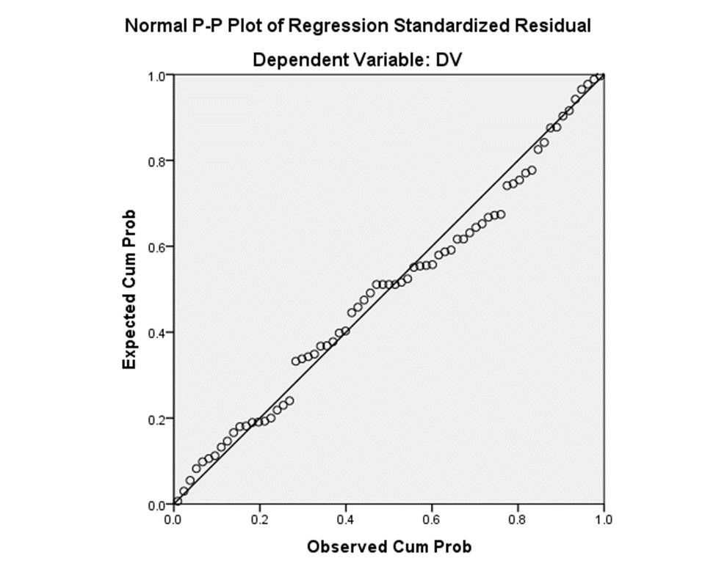

This graph shows positive behavior. Therefore, it visually interprets that all independent variables increase youngest crowd **Entrepreneurial Intention among Generation Z in Sri Lanka**

### Summary Table

**Model Summaryb**

|  |  |  |  |  |
| --- | --- | --- | --- | --- |
| Model | R | R Square | Adjusted R  Square | Std. Error of the Estimate |
| 1 | .685a | .470 | .437 | 1.070 |

1. Predictors: (Constant), IV4, IV2, IV3, IV1
2. Dependent Variable: DV

**Model R:** This value is the correlation coefficient between the observed values of the dependent variable (DV) and the predicted values from the model. In this specific case, the value is 0.685.

**R Square:** Also known as the coefficient of determination, R Square quantifies the proportion of the variance in the dependent variable that can be attributed to the variance in all the independent variables combined. In this model, approximately 47.0% (0.470) of the variability in

"Entrepreneurial Intention among Generation Z in Sri Lanka" can be explained by variations in the set of independent variables (IV4, IV2, IV3, IV1).

**Adjusted R Square:** This value adjusts R Square to account for the number of predictors in the model, providing a more accurate measure of the model's explanatory power. In this case, it's

0.437.

**Std. Error of the Estimate:** This estimate provides information about how well the model's predictions align with the actual data points by indicating the standard deviation of the residuals, which are the differences between observed and predicted values. In this instance, the standard error is 1.070.

### ANOVA Table

#### ANOVAa

|  |  |  |  |  |  |  |
| --- | --- | --- | --- | --- | --- | --- |
| Model |  | Sum of Squares | df | Mean Square | F | Sig. |
| 1 | Regression | 64.952 | 4 | 16.238 | 14.170 | .000b |
|  | Residual | 73.338 | 64 | 1.146 |  |  |
|  | Total | 138.290 | 68 |  |  |  |

1. Dependent Variable: DV
2. Predictors: (Constant), IV4, IV2, IV3, IV1

### Coefficients Table

**Coefficientsa**

|  |  |  |  |  |  |  |  |  |  |
| --- | --- | --- | --- | --- | --- | --- | --- | --- | --- |
| Model | | Unstandardized  Coefficients | | Standardize d  Coefficients | t |  | Sig. | 95.0% Confidence Interval for B | |
| B | Std. Error | Beta |  |  | Lower Bound | | Upper Bound |
| 1 (Constant  ) | | .094 | .612 |  |  | .153 | .879  .036  .641 | -1.129 | 1.316 |
| IV1 | | .097 | .046 | .342 |  | 2.138 | .006 | .189 |
|  | IV2 | .062 | .133 | .067 |  | .469 | -.203 | .327 |
|  | IV3 | .027 | .068 | .053 |  | .391 | .697 | -.109 | .162 |
|  | IV4 | .134 | .057 | .316 |  | 2.361 | .021 | .021 | .247 |

a. Dependent Variable: DV

C = 0.094

IV1 = 0.097

IV2 = 0.062

IV3 = 0.027

IV4 = 0.134

Y = IV1 + IV2 + IV3 + IV4 + C

Y (Entrepreneurial Intention among Generation Z in Sri Lanka) = 0.097 (Attitudes) + 0.062

(Personality Traits) + 0.027 (Subjective and Social norms) + 0.134

(Entrepreneurial Opportunities) + 0.094

### Reliability

**IV1**

**Case Processing Summary**

|  |  |  |  |  |
| --- | --- | --- | --- | --- |
|  |  | N |  | % |
| Cases | Valid |  | 69 | 100.0 |
| Excludeda |  | 0 | .0 |
| Total |  | 69 | 100.0 |

a. Listwise deletion based on all variables in the procedure.

**Reliability Statistics**

|  |  |
| --- | --- |
| Cronbach's  Alpha | N of Items |
| .882 | 9 |

**IV2**

#### Case Processing Summary

|  |  |  |  |
| --- | --- | --- | --- |
|  |  | N | 100.0 |
| Cases | Valid | 69 |
| Excludeda | 0 | .0 |
| Total | 69 | 100.0 |

a. Listwise deletion based on all variables in the procedure.

**Reliability Statistics**

|  |  |
| --- | --- |
| Cronbach's  Alpha | N of Items |
| .837 | 2 |

**IV3**

#### Case Processing Summary

|  |  |  |  |  |
| --- | --- | --- | --- | --- |
|  |  | N |  | % |
| Cases | Valid |  | 69 | 100.0 |
| Excludeda |  | 0 | .0 |
| Total |  | 69 | 100.0 |

a. Listwise deletion based on all variables in the procedure.

**Reliability Statistics**

|  |  |
| --- | --- |
| Cronbach's  Alpha | N of Items |
| .675 | 5 |

**IV4**

#### Case Processing Summary

|  |  |  |  |
| --- | --- | --- | --- |
|  |  | N | 100.0 |
| Cases | Valid | 69 |
| Excludeda | 0 | .0 |
| Total | 69 | 100.0 |

a. Listwise deletion based on all variables in the procedure.

**Reliability Statistics**

|  |  |
| --- | --- |
| Cronbach's  Alpha | N of Items |
| .739 | 6 |

DV

#### Case Processing Summary

|  |  |  |  |  |
| --- | --- | --- | --- | --- |
|  |  | N |  | % |
| Cases | Valid |  | 69 | 100.0 |
| Excludeda |  | 0 | .0 |
| Total |  | 69 | 100.0 |

a. Listwise deletion based on all variables in the procedure.

**Reliability Statistics**

|  |  |
| --- | --- |
| Cronbach's  Alpha | N of Items |
| .543 | 2 |

**ALL VARIABLE**

#### Case Processing Summary

|  |  |  |  |
| --- | --- | --- | --- |
|  |  | N | 100.0 |
| Cases | Valid | 69 |
| Excludeda | 0 | .0 |
| Total | 69 | 100.0 |

a. Listwise deletion based on all variables in the procedure.

**Reliability Statistics**

|  |  |
| --- | --- |
| Cronbach's  Alpha | N of Items |
| .926 | 24 |

# DISCUSSION

**Attitudes and Perceptions:**

The research indicates that Generation Z individuals in Sri Lanka exhibit positive attitudes towards entrepreneurship, viewing it as a viable and attractive career option. This aligns with previous studies that suggest the contemporary youth generation is increasingly drawn to the idea of creating their own ventures. The positive perceptions can be attributed to the evolving societal perception of entrepreneurship as a pathway to innovation, autonomy, and economic growth.

**Technological Familiarity and Adoption:**

The study underscores the crucial role of technology in shaping the entrepreneurial intentions of Generation Z. Their high level of technological familiarity suggests a propensity to leverage digital tools for business purposes. This resonates with the broader trend of digitalization impacting various industries. The findings highlight the need for tailored strategies to harness this familiarity and integrate technology effectively into entrepreneurial ventures.

**Cultural Influences and Modern Dynamics:**

The research unearths the intriguing dynamic between traditional cultural values and modern influences on the entrepreneurial intentions of Generation Z. While cultural norms can act as a guiding force, the influence of globalization and technological advancements is reshaping traditional mindsets. This resonates with the notion of a globalized youth culture navigating a balance between heritage and modernity.

**Policy and Ecosystem Implications:**

The research findings have significant implications for policy formulation and ecosystem development. To support the entrepreneurial aspirations of Generation Z, policymakers should prioritize integrating entrepreneurship education into schools and universities, tailoring funding mechanisms for young entrepreneurs, and creating an environment conducive to technological innovation. The establishment of innovation hubs and mentorship programs can also bolster their entrepreneurial journey.

**Educational Relevance:**

The study underscores the relevance of education in shaping entrepreneurial intentions. By infusing curricula with practical entrepreneurial skills, educators can empower Generation Z to confidently embark on their entrepreneurial journeys. This aligns with the growing emphasis on experiential and hands-on learning methods.

**Industry Collaboration:**

The research emphasizes the potential for collaboration between industries and young entrepreneurs. Industry leaders can engage with Generation Z to understand their perspectives, capitalize on their innovative ideas, and guide them toward addressing real-world challenges. Such collaboration can lead to mutually beneficial outcomes for both parties.

**Limitations and Future Research:**

While this study offers valuable insights, it is not without limitations. The sample size and geographical scope may limit the generalizability of the findings. Additionally, the study predominantly focuses on individual-level factors, potentially overlooking broader macroeconomic and policy influences. Future research could explore these dimensions and conduct longitudinal studies to track the entrepreneurial trajectories of Generation Z over time.

## RECCOMENDATION

Based on the insights derived from this research on entrepreneurial intentions among Generation Z in Sri Lanka, several recommendations emerge to foster an environment that nurtures and supports the aspirations of this dynamic demographic:

1. Integrate entrepreneurship education into education: Collaborate with educational institutions to do this. Giving students practical skills, knowledge of business fundamentals, and exposure to real-world entrepreneurial situations, can aid in developing an entrepreneurial mindset from an early age.
2. Promote technical Knowledge: Create programs to improve Generation Z's technical literacy. This includes courses, lectures, and online resources that enable them to use technology properly in their companies.
3. Develop Mentorship Networks: Arrange mentorship programs that pair up young, aspiring entrepreneurs with seasoned specialists in the field. Such contacts can help Generation Z members overcome the difficulties of business by offering useful advice, insights, and networking possibilities.
4. Create Opportunities for Accessible Funding: help young entrepreneurs obtain access to financial sources that are suited to their needs. This could entail collaborations between financial institutions, entrepreneurs with venture capital, and governmental organizations to provide grants, low-interest loans, and investment exclusively for enterprises established by members of Generation Z.
5. Promote Innovation Hubs: Develop co-working areas and innovation hubs that promote young entrepreneurs' collaboration, creativity, and information sharing. These places may offer access to materials, equipment, and a friendly community that encourages the development of new businesses.

1. Appreciate Variety: Recognize and celebrate the different opinions and backgrounds of members of Generation Z. Encourage projects that demonstrate the potential advantages of blending conventional values with current commercial processes, creating a distinctive and interesting entrepreneurial ecosystem.
2. Engage with Role Models: Set up gatherings and forums where successful young entrepreneurs can share with Generation Z about their adventures and experiences. These entrepreneurs serve as role models for aspiring entrepreneurs, showing them that success is possible.

1. Support research and innovation by providing funds to promote research on entrepreneurship among Sri Lanka's Generation Z. This could include supporting academic research, innovative initiatives, and team research projects that provide the spotlight on new trends and business opportunities.
2. Leverage Digital Platforms: Make advantage of social media and online venues to promote entrepreneurship, share success tales, and offer resources to young entrepreneurs. Generation Z can be reached and engaged efficiently using various methods.

1. Collaborative Environment Development: Support cooperation between public institutions, universities, professional associations, and private enterprises to build a strong ecosystem that promotes Generation Z entrepreneurs. By coordinating activities, a holistic environment that promotes their success and growth can be created.

# CONCLUSION

The entrepreneurial targets of Generation Z in Sri Lanka stand out as an important field of investigation in a world marked by swift technical breakthroughs and changing cultural and social environments. This study explored all of the factors that influence this generation's entrepreneurial goals, exposing their attitudes, views, and the variables affecting their decision-making process.

The research showed how important technology is to Generation Z people's lives and how it affects their capacity for entrepreneurship. The results highlighted the complex interplay between traditional cultural values and modern influences, highlighting the importance of understanding the particular dynamics that determine their goals.

This study contributes to a more thorough understanding of Sri Lanka's entrepreneurial environment by highlighting elements including individual attitudes, believed behavioral control, technical familiarity, and cultural influences. Insights from the study can help legislatures, educators, and entrepreneurs develop plans to encourage and promote Generation Z's entrepreneurial spirit.

Their goals have the ability to encourage innovation, reshape sectors, and support the country's sustainable growth as Generation Z takes the lead in the economic and social transition. The findings of this study, which were derived from a combination of quantitative data and qualitative narratives, provide an integrated view on the entrepreneurial intentions of Generation Z in Sri Lanka and can be used as a foundation for targeted initiatives and informed choices.

# REFERENCES

[1] Youtube, "Youtube," Google LLC, [Online]. Available: https://www.youtube.com/. [Accessed 2023].

# APPENDICES

Gantt Chart

|  |  |  |  |
| --- | --- | --- | --- |
| **Task Name** | **July** | | **Augst** |
| **3** | **4** | **1** |
| **Identify the Research**  **Idea** |  |  |  |
| **Planning the Research** |  |  |  |
| **Data Collection** |  |  |  |
| **Data Analysis** |  |  |  |
| **Create Final Report** |  |  |  |
| **Final Presentation** |  |  |  |